Supplementary Materials to the manuscript “Functional impact of MRGPRX2 single-nucleotide polymorphisms on drug-induced cellular responses in vitro”

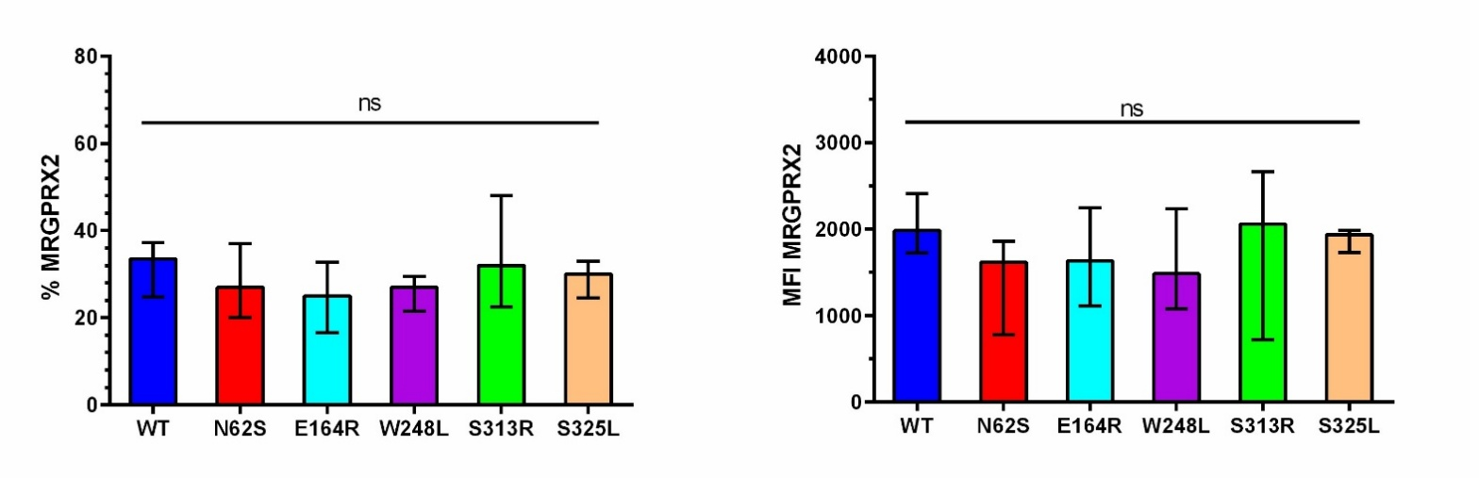
Supplementary Fig. 1. Across independent experiments, neither the percentage of MRGPRX2-positive cells (% MRGPRX2) nor the geometric mean fluorescence intensity (MFI MRGPRX2), as assessed by flow cytometry, differed significantly between the variants. Statistical analysis was performed using the Kruskal–Wallis test followed by Dunn’s post hoc test. Differences were considered statistically significant at p < 0.05; ns, not significant.

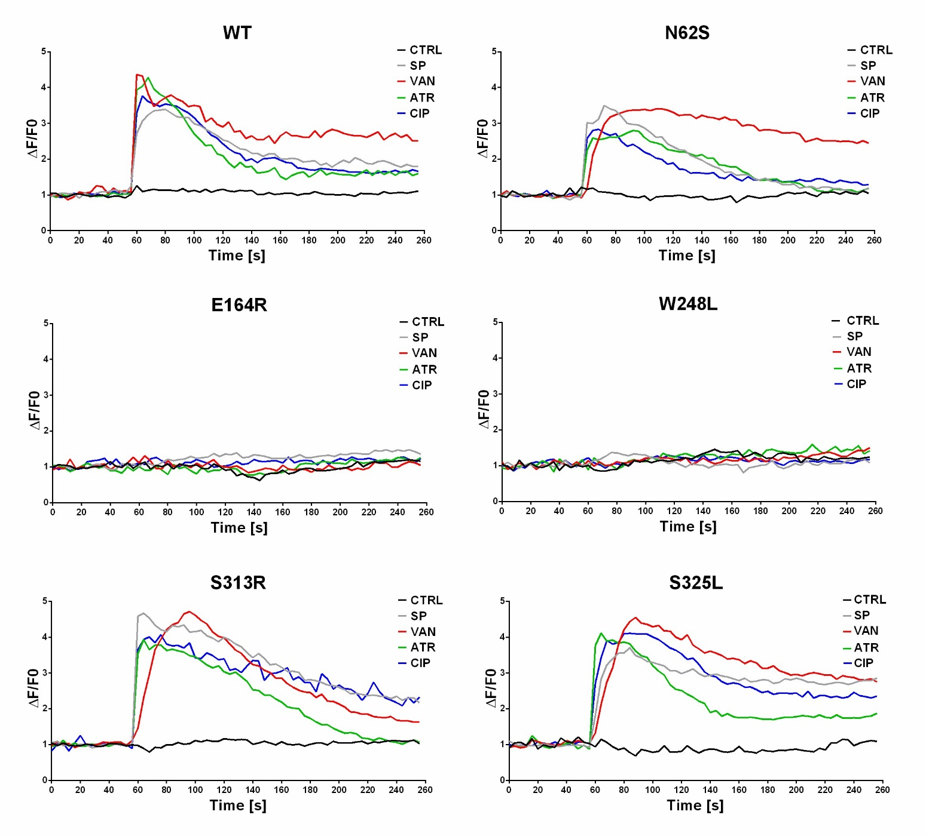
Supplementary Fig. 2. Representative Ca²⁺ fluorescence traces for WT-MRGPRX2 and its variants under investigations. ΔF/F₀ was recorded 60 s before and 200 s after stimulation.

